

Medical Devices

Digital Modulated Radiography
A Novel Approach to Radiography
Radiography is an imaging technique using ionizing and non-ionizing forms of radiation to view objects. In conventional radiography, an image is obtained with a given set of those parameters based on the image task, anatomical makeup, and region of interest. Although such parameters are optimized over the whole image area or volume, they may not be necessarily optimal for every sub-region of the image. Therefore, a new method is warranted to obtain more precise images.

The technology
Virginia Commonwealth University researchers have developed a novel method called “Digital Modulated Radiography” in which a digital radiographic image (often known as digital x-ray image) is provided with single, multiple sub-areas, or sub-volumes, which provides more precise images and more information to a healthcare team compared to conventional radiography methods. Software companies, imaging device vendors and radiotherapy machine manufacturers can take advantage of this innovation that offers a superior approach to imaging.

A digital modulated radiographic image is by an optimal combination of 3 components: image intensity, radiation intensity, and radiation energy.

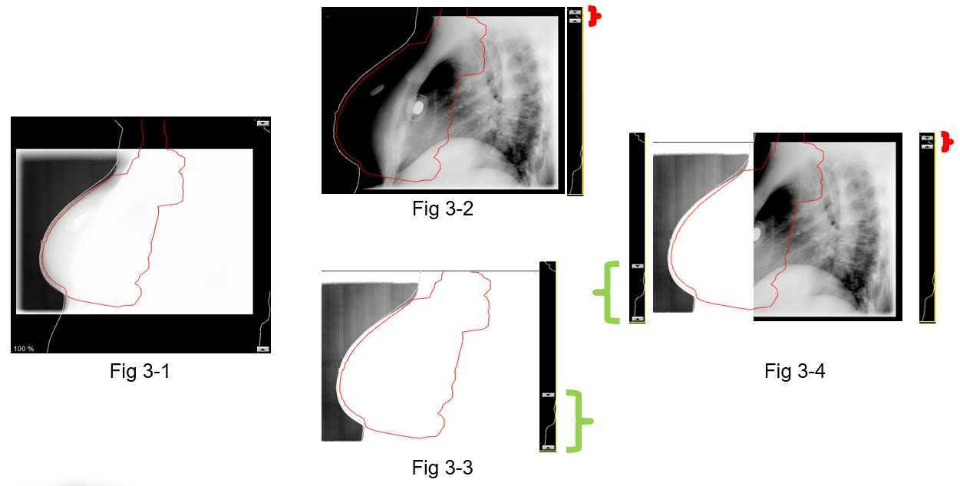
Figure 1: An example how modulated radiography can be used for patient setup in breast radiation therapy

Benefits
- Enhanced imaging precision
- Increased Diagnostic Information
- Simplified Medical Interpretation

Applications
- Radiological Procedures
- Image-Guided Radiation Therapy

Patent status:
Patent pending: U.S. and foreign rights are available.

License status:
This technology is available for licensing to industry for further development and commercialization.

Category:
Biomedical

VCU Tech #:
23-097

Investigators:
Siyong Kim, PhD
Richard Wargo, M.S., DABR

Contact us about this technology

Brittaney Ritchie, MS
Business Development and Medical
Devices Licensing Manager
ritchieb@vcu.edu
(703) 554-5637

